4.6_Homework.R

jason

Tue May 03 10:51:00 2016

#4.6 Homework #88,94  
  
######## #88 ###########  
  
#Given velocity data  
velocity=c(69.0,69.7,72.7,80.3,81.0,85.0,86.0,86.3,86.7,87.7,89.3,90.7,91.0,92.5,93.0)  
  
#Given percentile data  
percentiles=c(-1.83,-1.28,-.97,-.73,-.52,-.34,-.17,0,.17,.34,.52,.73,.97,1.28,1.83)  
  
#create 4 plots on one picture  
par(mfrow=c(2,2))  
  
#Create a Histogram of the velocity and percentiles  
hist(velocity)  
hist(percentiles)  
  
#Create a dotplot of the velocity and percentiles  
dotchart(velocity)  
dotchart(percentiles)

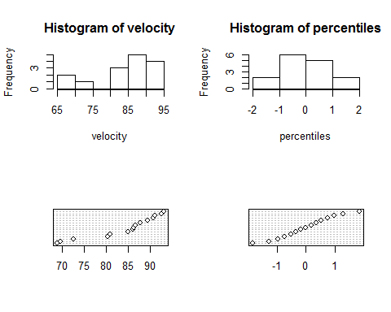

#No, both distributions are not normal, as they are not symmetrical, or in a bell-curved shape  
  
  
########## #94 #############  
  
dataValues = c(.77,1.2,3,1.62,2.81,2.48,1.74,.47,3.09,1.31,1.87,  
 .96,.81,1.43,1.51,.32,1.18,1.89,1.2,3.37,2.1,.59,1.35,.90,1.95, 2.2,.52,.81,4.75,2.05)  
  
#a.)  
  
#Create image with two pictures on it  
par(mfrow=c(1,2))  
  
#Convert data into histogram  
hist(dataValues)  
  
#Draw normal probability plot  
qqnorm(dataValues)  
  
#Draw line on normal probability plot  
qqline(dataValues)

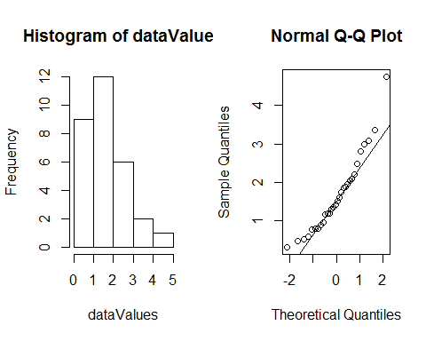

#b.)  
  
#Take square root of dataValues  
rootedDataValues = dataValues^(.5)  
  
#Create image with two plots  
par(mfrow=c(1,2))  
  
#Convert into histogram and draw normal probability plot with line  
hist(rootedDataValues)  
qqnorm(rootedDataValues)  
qqline(rootedDataValues)

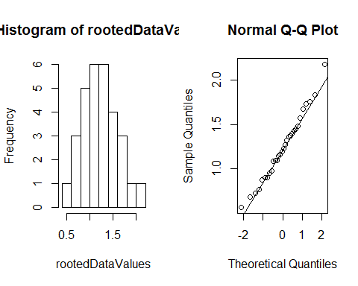

#Yes, the square rooted values seem to represent a normally distributed data set  
  
  
#c.)  
  
#Take cube root of datavalues  
cubeRootedDataValues = dataValues^(1/3)  
  
#Create image with two plots  
par(mfrow=c(1,2))  
  
#Convert into histogram and draw normal probability plot with line  
hist(cubeRootedDataValues)  
qqnorm(cubeRootedDataValues)  
qqline(cubeRootedDataValues)

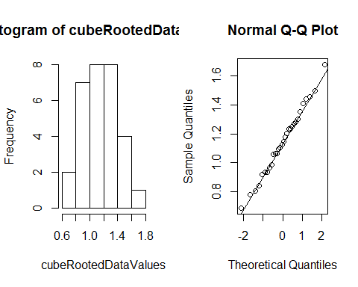

#Yes, the cube rooted data values also seem to represent a normally distributed data set